IV. Centers for Disease Control and Prevention West Nile Virus - http://www.cdc.gov/ncidod/dvbid/westnile/index.htm: Recent and archived maps and data on WNV incidence and background information on WNV.

- This web site has many links to information on WNV. Clicking on the Maps & Human Cases link leads to the Statistics, Surveillance and Control Archive page. Under Maps and Data there are options for many sources of data.

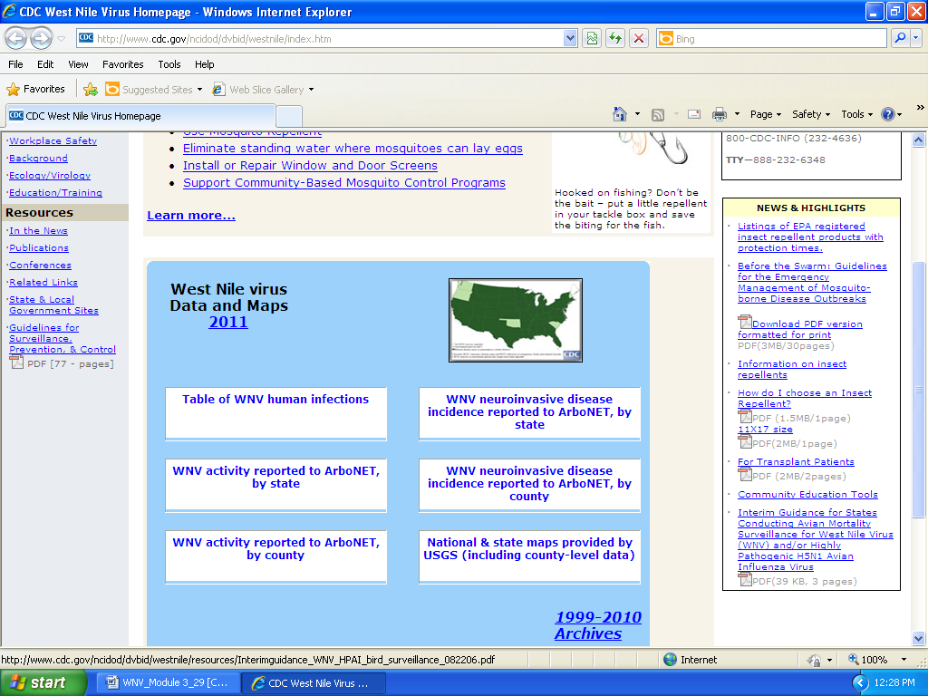

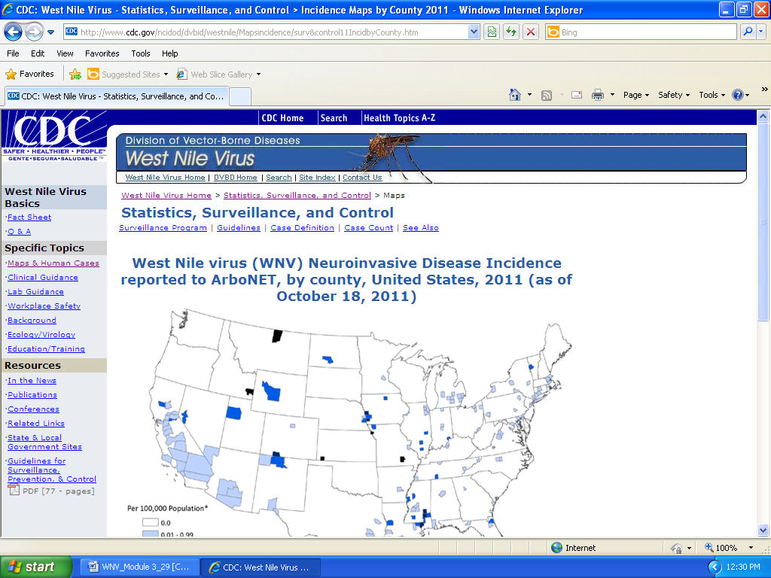

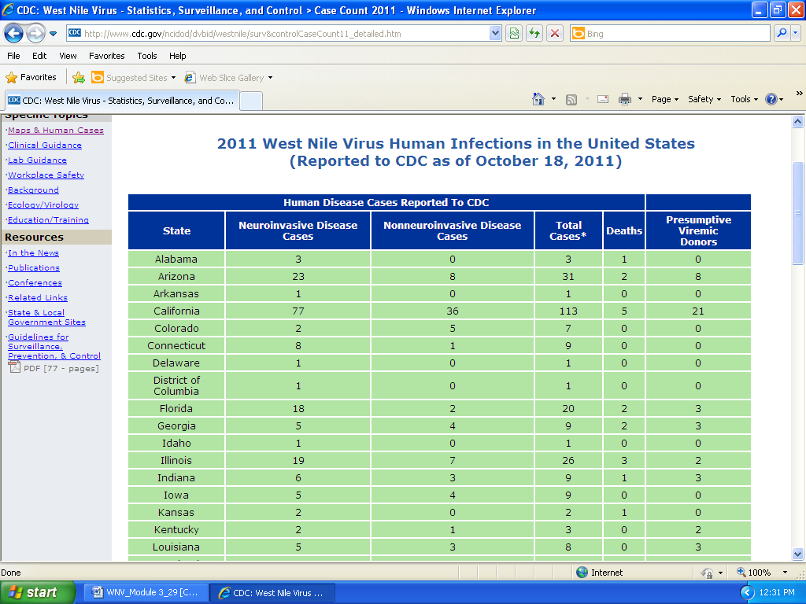

- Data comparing WNV to other arboviruses can also be found on this site.

